CampusTalk

Feasibility Report

Document Version | 1.0
Prepared By | Software Engineering Team – 05
Department | MSc. I.T. 2011
Submitted To | Prof. Asim Benerjee
Date of Sumission | 13th Aug 2012

Team:
Name | ID
Piyush Gupta | 201112007
Sunnykumar Lalwani. | 201112033
Darshil Shah | 201112035
Shreeji Patel | 201112057
Faishal Saiyed | 201112071
Ravi verma | 201112081
Hiral Shah | 201112089

Table of Contents

Introduction 3

Project Scope 3

Preliminary Requirements...…………………………………………………………….....4

Suggested Deliverables …………………………………………………...............4

Technical Requirements…………………………………………………………………...5

Feasibility Analysis………………………………………………………………………..6

Operation Feasibility………………………………………………………………6

Technical Feasibility………………………………………………………………6

Schedule Feasibility……………………………………………………………….6

Project Plan………………………………………………………………..7

Gantt chart………………………………………………………………...7

Economic Feasibility………………………………………………………………8

Software Development Model …………………………………………………………….8

Stakeholders 9

Glossary 11

References 11

Introduction

The students of DA-IICT are facing the problem to connect with each others within campus offline. They cannot have any offline platform to connect with each others which allows them to share information about various events, and knowledge. Facing difficulties to connect with various group members when they want to have certain discussion about their academic project or have others information to share. Even students and professors do not have any way to share their knowledge to each others. The only way to communicate with each others is mailing system of institute. But it’s not an efficient way to share knowledge.

There are various social networks platform available for the same, but as they are restricted by institute authorities for accessing during the study time. So this would be not a solution to the problem.

The only solution is proposed system by software engineering team 05 of M.Sc. IT 2011 batch. This system addresses all such issues/difficulties of students, professors for sharing offline within campus.

Project Scope

Campus Talk is an Intranet-based College network helps connect with students, professors and fellow batch mates offline. It can be used to share opinions, announcements, etc. publicly to all the students without any need of using third-party networking service. College has full control over the access of the service and users who wish to use it.

System is accessible on campus intranet, and can access by only authorized users of the system like registered professors and students. System access is bounded for campus communication of authorized users with the proposed features.

System may be expanded to use by others colleges/institute for their internal communication and sharing purpose.

In Scope | Out Scope
Intranet Network for Students and Professors | Non-college Students will not be the users

Preliminary Requirements Analysis

The following will define the preliminary requirements of the system.
- Admin Control Panel for Configuring/Skinning for particular College.

- Admin creates Batch Group in the site, and adds valid student email IDs that can belong to the group.

- Group members (belong to standard-user) can make “Markdown” formatted posts with Public or Private Visibility modes.

  - Public posts are visible to members of every batch, while Private posts are restricted to group members.

  - Professors (belong to super-user group) can see all the posts.

  - Anyone who can see the post, can comment it, or report for abuse.

  - 5+ abuse reports marks the post to be reviewed by moderator.
    - After reviewing the reported post, its up to moderator whether to keep it or remove it.

- Personal messaging between group members.

- Members of “super-user” group can mass-message to any batch for announcements.

- Events can be created by any member.

- Super-user can choose moderator for any batch group, or election can be created for moderator selection.

Suggested deliverables

Working application
Working module of the above mentioned features will be going to be delivered at the end, and used by institute (probably by DA-IICT students and professors for connecting to each others and share what they want.)

Source code
All the source files used to develop the system. It will also contain the database dump and other configuration, read me files.

User manual
Well organized user manual which can guide the user about how to use the system. The user manual contains the tutorial including snapshots of the system.

Documentation
The Document will contain information about the process followed to develop the system. It will give detailed information about the project and the development process to the reader. Include all design documents and may be development documents.

Technical requirements

The probable technical requirements for the development of the system are as follows:
- Tools to be used for development:
  - Eclipse or SpringSource (IDE)
  - Linux/Windows (Platform)
  - Git (for VCS)
- Frameworks
  - Spring
  - Hibernate
  - jQuery and other JavaScript frameworks.
  - HTML5/CSS3
- Supported Browsers
  - Chrome 11+
  - IE9+
  - Firefox 4+
  - Safari 4+
  - Opera 10+

Feasibility Analysis

Operational Feasibility

Since the technology which we have mentioned for development, are going to support all the features of proposed system. All the features like post, comment, messaging, are feasible to implement by the development team which will be going to address the issue of students, and professor’s for their offline communication.

All the system features are feasible to implement with the existing technology. This system helps campus users to communicate in better way. And will be accepted by users of proposed system as it will be providing efficient platform for sharing. What they want and when they want.

Technical Feasibility

It is possible to developed proposed system with existing technology. And developer’s team has knowledge about some of the mentioned technology. There are some technologies which need to learn by development team but it is feasible for them to learn and implement all the system features using such technologies.

Schedule Feasibility

After understanding the preliminary system requirements thoroughly, technologies available to solve the problems and the size of the team available, the team is ready to complete the project successfully within three months of its commencement. With proper planning and management of our schedule, project will be feasible.
Project plan

←--- remove these diagram or change with our system if possible -→

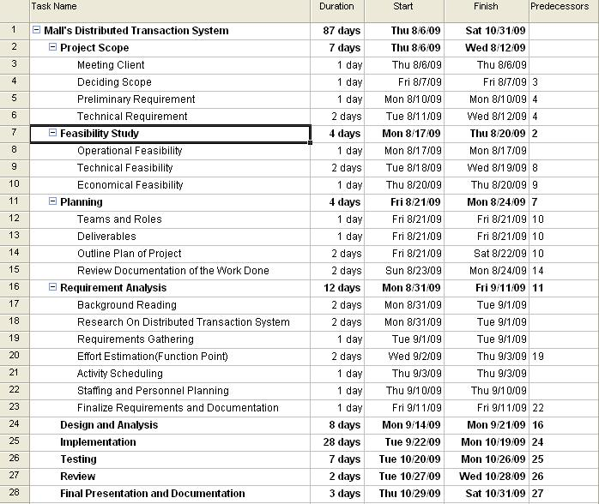

Gantt chart

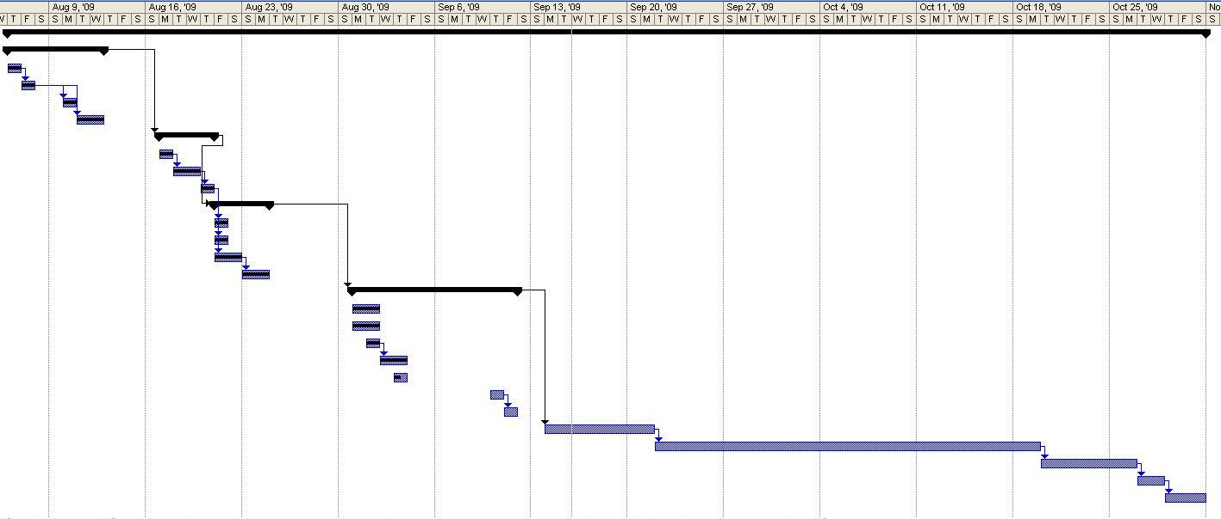

Economy Feasibility

Type | Potential Costs
Hardware | Not Applicable  No need of integration of any kind of hardware device apart from the development machines. Not required to invest on any types of external hardware
Software | Open source  No cost for the development of the system using proposed software technology
Training/ Maintenance Cost | Training Cost: no need of any formal training as of now, as it is developed for the Institute like DA-IICT, students and professor already have idea about how to operate such system  Maintenance Cost: required minimal cost for payment to those users who will be going to maintain system like admin and moderator whose responsibility to keep system update and control the system access.

Feasibility Study Result:

Feasibility Component | Feasible  Yes/ No | Level  High/Medium/ Low
System Feasibility on operation level? | Yes | High
System Feasibility on Technical Level? | Yes | High
System Feasibility on Economical Level? | Yes | High
System Feasibility on Schedule Level? | Yes | Medium

Software Development Model

We are planning to follow the sequential Model.

As all system requirements are well defined in nature and can easily be identified during the first phase of requirement analysis. There might be little likelihood to change in requirement specification. Therefore it is efficient to follow sequential approach of software development life cycle with revised version of implementation and design documents. If there is change in requirement specification it would be not difficult to incorporate within the developing system as the complexity of the system is not high.

Stakeholders

- Developers: The Developers are entitled the responsibility to make the product work. They would also be directly affected by exposure to a relatively newer technology used during the implementation of the System.

- System Users
End users of the system who will be going to used system and manage the system.

Admin
Moderator
Students
Professors

Glossary

IDE : Integrated Development Environment
VCS: Version Control System

